Project Planning Phase

Project Planning Template (Product Backlog, Sprint Planning, Stories & Story Points)
Date | 14 July 2026
Team ID | __________
Project Name | Shopezz – MERN E-Commerce Platform
Maximum Marks | 5 Marks

Product Backlog & Sprint Planning
Sprint | Epic | Story ID | User Story / Task | Points | Priority | Team
Sprint-1 | Authentication | US-01 | User registration with email verification | 3 | High | Team
Sprint-1 | Authentication | US-02 | Secure login using JWT | 3 | High | Team
Sprint-1 | Products | US-03 | Browse/search/filter products | 5 | High | Team
Sprint-2 | Cart | US-04 | Add/update/remove cart items | 5 | High | Team
Sprint-2 | Wishlist | US-05 | Wishlist management | 3 | Medium | Team
Sprint-3 | Orders | US-06 | Checkout & order placement | 8 | High | Team
Sprint-3 | Orders | US-07 | Order tracking | 5 | High | Team
Sprint-4 | Admin | US-08 | Manage products/categories | 8 | High | Team
Sprint-4 | Admin | US-09 | Manage users/orders & dashboard | 8 | High | Team

Sprint Schedule
Sprint | Story Points | Duration | Start | End | Completed
Sprint-1 | 14 | 7 Days | 10 Jul | 16 Jul | 14
Sprint-2 | 8 | 7 Days | 17 Jul | 23 Jul | 8
Sprint-3 | 13 | 7 Days | 24 Jul | 30 Jul | 13
Sprint-4 | 16 | 7 Days | 31 Jul | 06 Aug | 16

Velocity & Burndown
Total Story Points: 51
Sprint Duration: 7 Days
Average Velocity: 12.75 Story Points per Sprint.
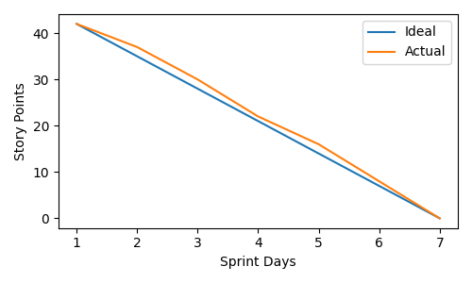

Project Planning Summary
The Shopezz project follows Agile Scrum with four sprints covering authentication, product catalog, cart, wishlist, orders, and admin modules. User stories are prioritized based on business value to ensure core customer features are delivered first while maintaining scalability and code quality.

